HighPoint Variable Sector Size

Single Storage Volumes Greater than 2TB (Terabyte)

Dec 12, 2007

Executive Statement

Accessing single storage volumes beyond 2TB (Terabytes) in a 32bit Operating System or 512 bytes disk sector size Operating systems i.e. (Windows 2000 or Windows XP) are only limited to a storage volume up to 2TB (Terabyte).

HighPoint has addressed the 2TB single storage volume in Windows 2000 and Windows XP with a new feature called Variable Sector Size. Variable Sector Size only designed for Data RAID Array or non-bootable RAID array. The default 32 bit OSs’ disk sector size is 512 Bytes so in order to allow OS see beyond 2 TBs partition or single array, HighPoint RocketRAID3000 series members offer Sector Size options up to 4K.

Maximum Storage Capacity support per partition / array for each disk Sector Size options.

Disk Sector Sizes | Max. Storage Capacity per partition
512B (Default disk Sector Size in 32bit OS) | 2 Terabytes
1 k | 4 Terabytes
2 K | 8 Terabytes
4 K | 16 Terabytes

The only disadvantage of choosing disk sector size larger then 512B is unable to support bootable Array /Partition. While, this is not end of the world because HighPoint allows user create multiple partitions or Arrays and user get to choose either default 512B or larger sector size configure to a single HighPoint RocketRAID 3000 series. In other words, for bootable array customer can stick with 2TBs and select beyond 512 B for beyond 2 Terabytes partition support.

This document will describe how to setup and configure Variable Sector Size (VSS) to support beyond 2 TBs storage capacity.
We offer 2 management interfaces allow users to configure Variable Sector Size features

- BIOS
- HighPoint Web GUI

RocketRAID Controller BIOS Update

Update the latest BIOS for their RocketRAID controller to support VSS. Download the latest BIOS for the RocketRAID controller from the HighPoint website. (www.highpoint-tech.com)

Once the card BIOS is updated users can proceed to setup and configure VSS.

Setting Up VSS (Variable Sector Size) in RocketRAID BIOS Interface

Step 1: Enter the RocketRAID BIOS by pressing the Ctrl-H hotkey.

Step 2: Once in the RocketRAID BIOS, all SATA hard drives connected to the RocketRAID controller are identified.

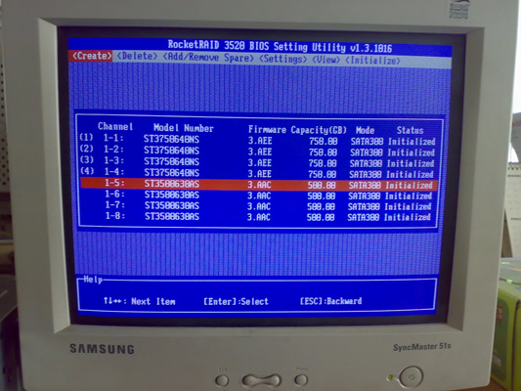

Step 3: Select the Advanced RAID Level (0, 5, 6, 10, 50 or JBOD) to configure and scroll down to the Sector Size. If the total capacity of the RAID array that is created is beyond 2TB the VSS option will be available.

Tab to the Sector Size option menu a “Warning” message will appear with information about changing the default sector size from 512 to another value.
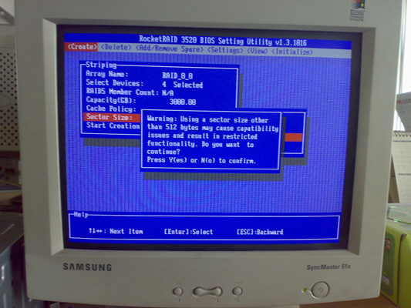

Step 4: Select the Sector Size that matches the total storage space for the RAID array.

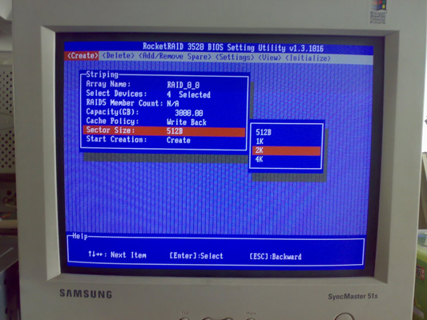

Variable Sector Size options

Boot to RocketRAID Controller and VSS Support

Before continuing – The RocketRAID controller supports booting to the OS and VSS on the same controller using the same storage. The RocketRAID controllers support partition based RAID - enter the capacity for the RAID in MB (Megabyte). The setup and configuration steps are below.

Step 1: Select RAID level and the total number of drives.

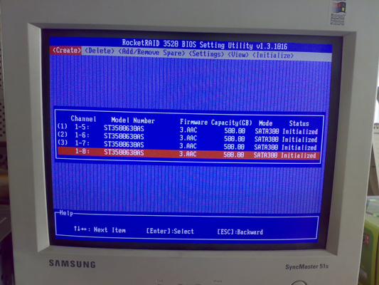

Step 2: Enter the capacity in MB (Megabyte) and create the RAID array.
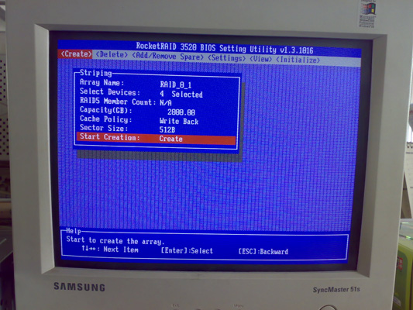

Step 3: Once the RAID array is created configure the remaining storage space using the VSS feature. Follow the steps (Setting Up VSS (Variable Sector Size)) again.

Setup and Configuration of VSS with HighPoint Web GUI

Step 1: Log into HighPoint Web GUI, Select the drives for the RAID array and select the Sector Size.

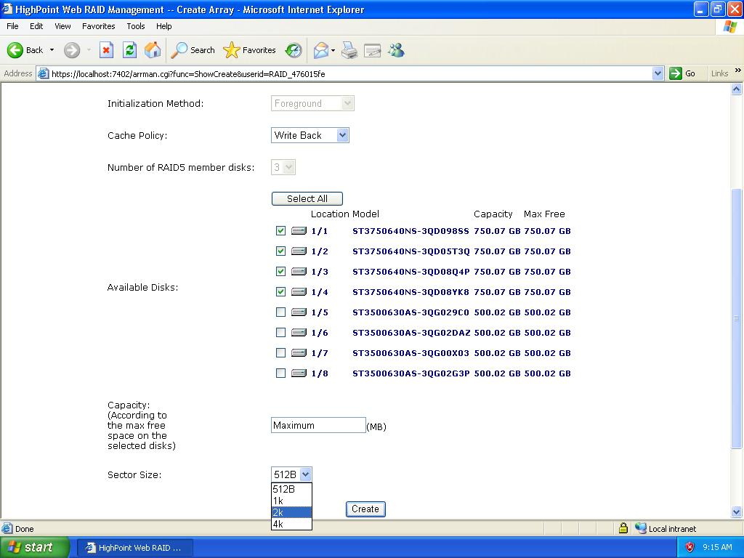

Disk Sector Size Options

Step 2: When changing the Sector Size from 512 to a different value a warning message will appear about compatibility issues.

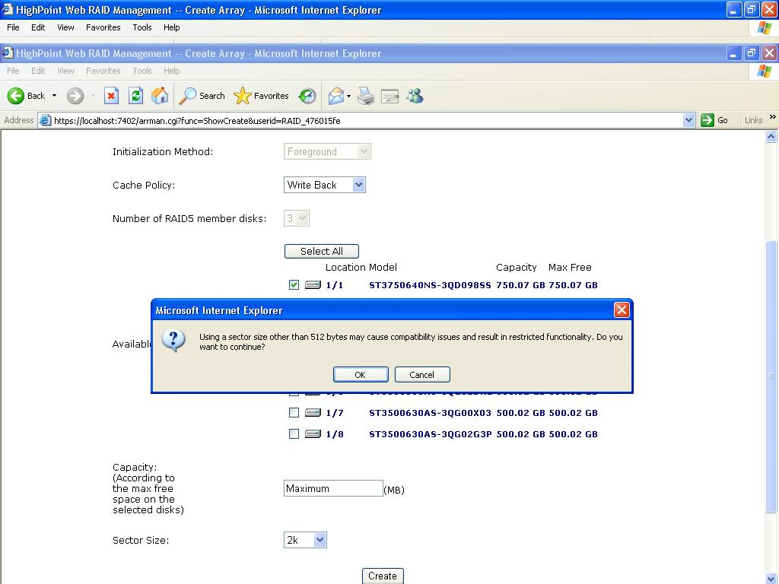

2k Disk Sector Size selected

Step 3: When the RAID array is created successfully, there will be a prompt. The total capacity will be displayed for the RAID array.
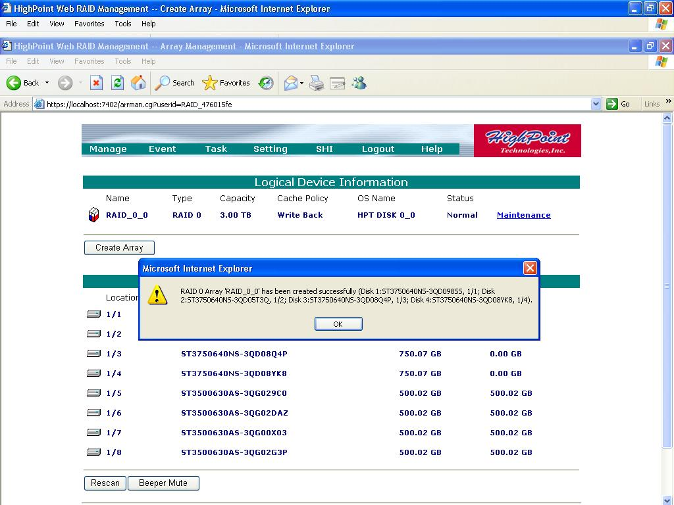

Once completed Variable Sector Size configurations In HighPoint management Interface

Beyond 2TBs partition shows in Windows Disk Management

Step 1: Start Windows Disk Management and prepare to configure the newly added space beyond 2TB (Terabyte)
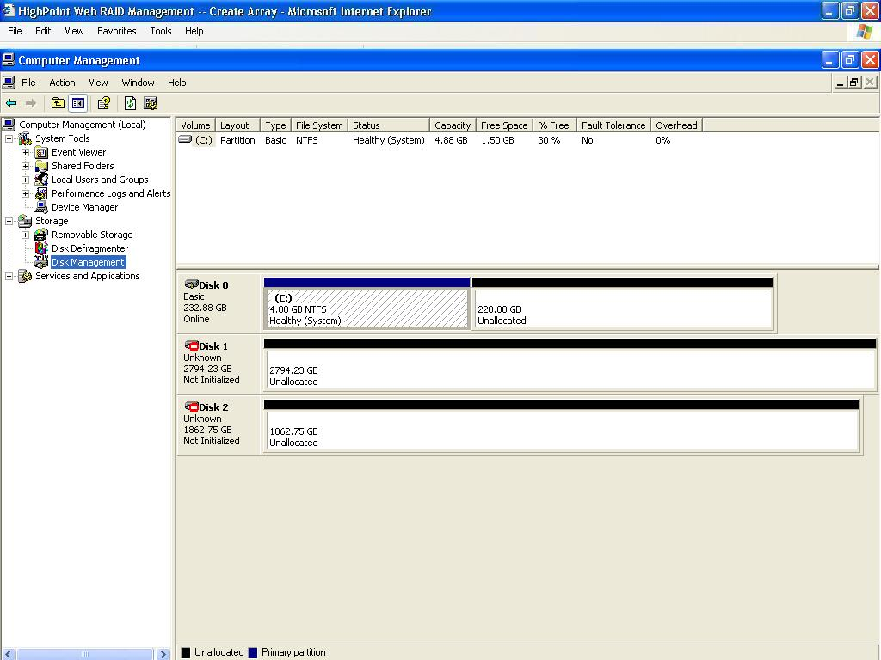

Support larger than 2 Terabytes.

Step 2: Right Click to “initialize the space for Windows”

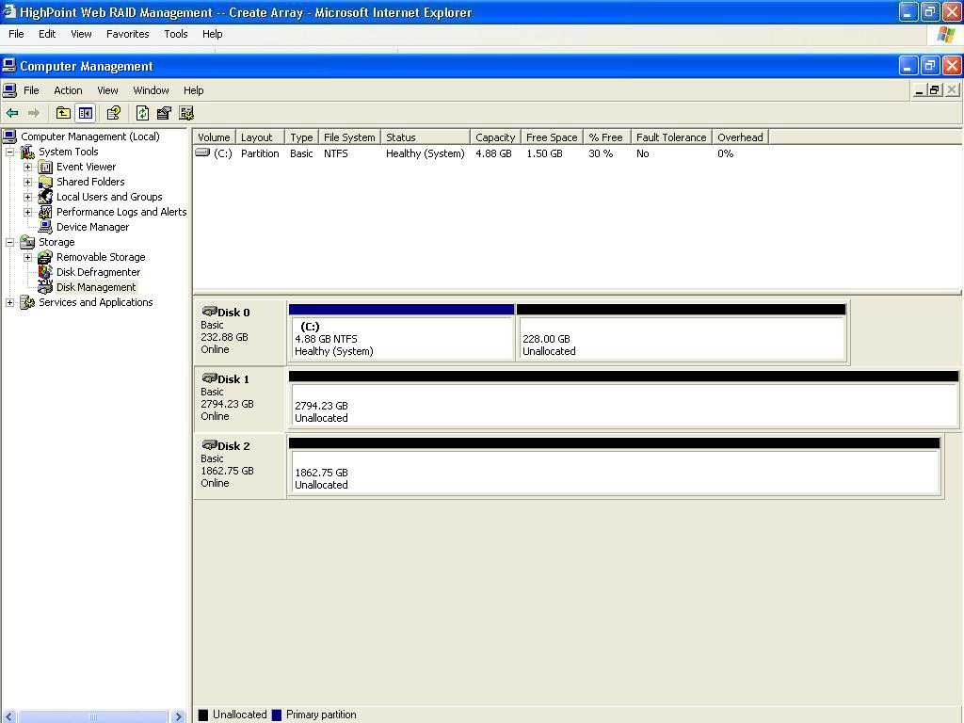

Step 3: Use the Windows Disk Management utilities to partition and format the newly added space. There will be a single storage volume beyond 2TB made available on the Windows desktop.
